Software Engineering Lab Test
Library Management System
Duration: 45 Minutes

1. Problem Statement
- Libraries manage large numbers of books and users manually, which is slow and error-prone.
- A Library Management System (LMS) automates book search, issue, return, and record management.
- It reduces human errors and saves time for both students and librarians.

2. Sub-Problems
- Difficult to search books manually from a large collection.
- No proper tracking of issued/returned books and due dates.
- Duplicate records due to lack of a centralized database.
- No access control — anyone can modify records without permission.

3. Stakeholders
- Student: Searches books, requests issue and return of books.
- Librarian: Manages book records and approves issue/return requests.
- Admin: Has full access — manages users, books, and system settings.

4. Software Requirements Specification (SRS)

4.1 Functional Requirements
- Users can log in using username and password.
- Students can search books by title, author, or ISBN.
- Librarian can issue books to registered students.
- System records book return and updates availability.
- Admin can add, edit, or delete books and user accounts.

4.2 Non-Functional Requirements
- Security: Passwords are encrypted; access is role-based.
- Performance: Search results load within 2 seconds.
- Reliability: System has 99% uptime with no data loss.
- Usability: Simple interface — no technical knowledge needed.
- Availability: Available during library hours (8 AM – 8 PM).

4.3 Constraints
- Must run on a standard PC with a modern web browser.
- Must support minimum 10,000 books and 1,000 user records.

5. System Modules
- Login Module: Verifies user credentials and redirects to role-based dashboard.
- Search Book Module: Allows users to search books and check availability.
- Issue/Return Module: Records book issue date, due date, and return date.
- Database Module: Stores all book, user, and transaction records.

6. DFD (Data Flow Diagram)

Level-0 DFD
- Shows the entire system as one process: 0.0 Library Management System.
- Inputs: Book Request, Book → Process → Output: Book Info to Display Book.
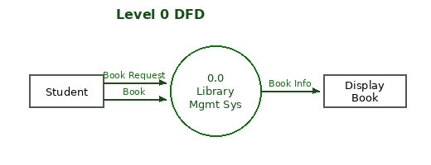

Level-1 DFD
- 1.0 Search Book: Student sends Book Request → system searches Book DB.
- 2.0 Issue Book: Book selected → system records transaction in Book DB.
- 3.0 Update Records: Admin/Librarian updates data in Records DB.
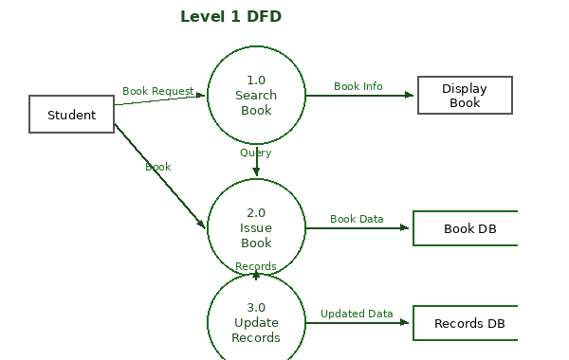

Level-2 DFD (Breakdown of Search Book)
- 1.1 Enter Book Title: Student types the book title into the search form.
- 1.2 Find Book in Database: System queries Book DB and fetches matching records.
- 1.3 Display Book Information: System shows title, author, and availability to student.
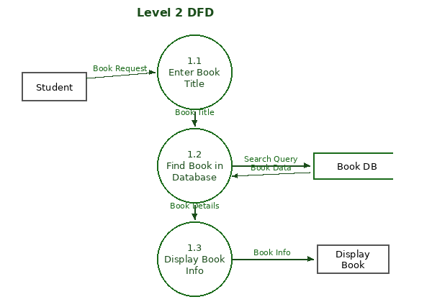

7. HTML Module – Login Page
Simple login form with username, password, and login button:
<!DOCTYPE html>
<html>
<head>
<title>Library Login</title>
</head>
<body>
<h2>Library Login</h2>
<form>
Username: <input type="text" name="username"><br><br>
Password: <input type="password" name="password"><br><br>
<input type="submit" value="Login">
</form>
</body>
</html>

8. HTML Module – Module Selection
Dropdown form to select a library module:
<!DOCTYPE html>
<html>
<head>
<title>Select Module</title>
</head>
<body>
<h2>Library Module Selection</h2>
<form>
Select Module:
<select name="module">
<option>Search Book</option>
<option>Issue Book</option>
<option>Return Book</option>
<option>Update Records</option>
</select>
<br><br>
<input type="submit" value="Open Module">
</form>
</body>
</html>

Library Management System | Lab Test Answer Sheet

